IBM CLOUD

TEAM LEAD- SHREYA B.T

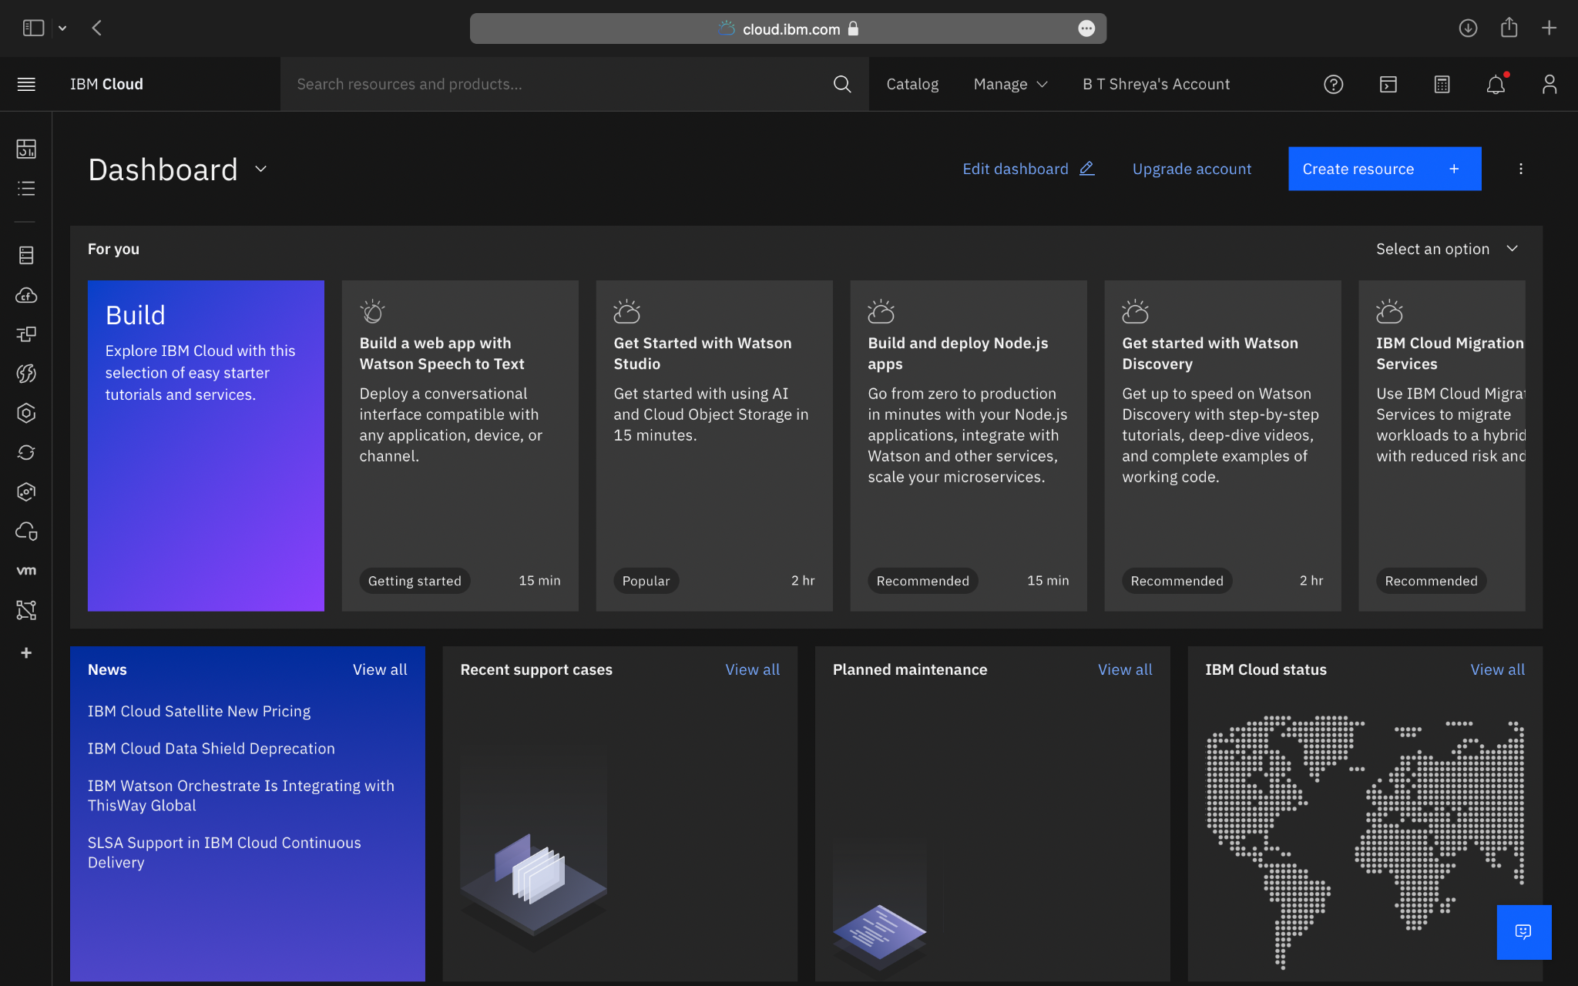

TEAM MEMBER – CHETANA S

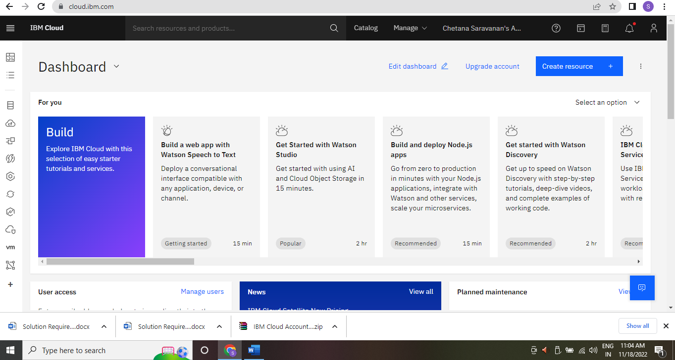

TEAM MEMBER-DEVA DHARSHINI S

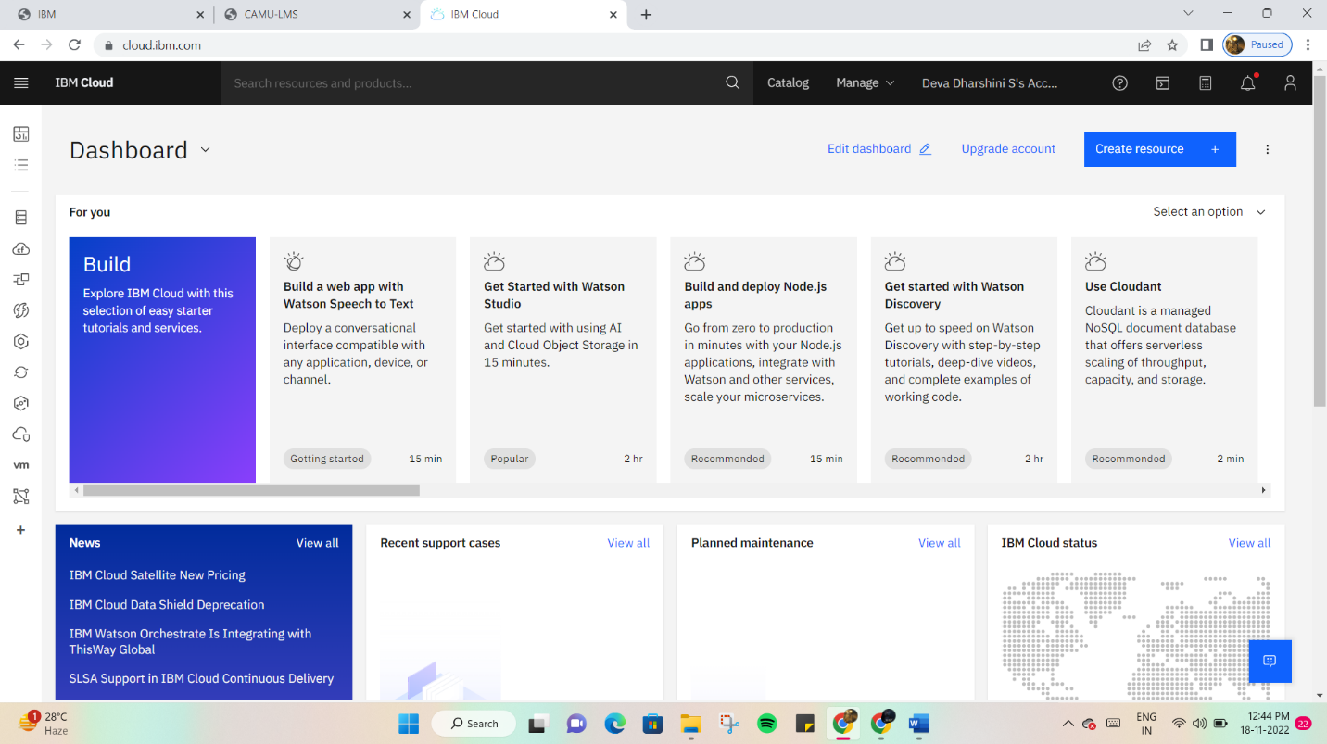

TEAM MEMBER-PRIYADHARSHINI M

